**How to hide Automation tool bar warnings in Chrome:**

When you are running the tests in chrome you will see the information bar saying “Chrome is being controlled by automated test software”. It won’t cause any harm to your automation but it will be annoying to see these kind of information messages sometimes. You can disable them using chromeoptions.

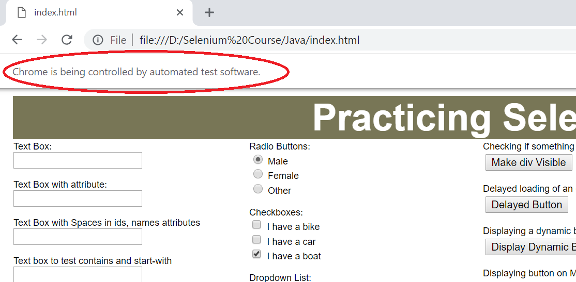

**package** Selenium;

**import** org.openqa.selenium.WebDriver;

**import** org.openqa.selenium.chrome.ChromeDriver;

**import** org.openqa.selenium.chrome.ChromeOptions;

**public** **class** AutomationBar {

**public** **static** **void** main(String[] args) {

//Disabling Chrome push notifications

ChromeOptions ops = **new** ChromeOptions();

ops.addArguments("disable-infobars");

System.*setProperty*("webdriver.chrome.driver", "C:\\BrowserDrivers\\chromedriver.exe");

WebDriver driver = **new** ChromeDriver(ops);

driver.manage().window().maximize();

driver.get("file:///D:/Selenium%20Course/Java/index.html");

}

}